

Fontsize:40px Fontfamily: Fredoka One Color:white



Fontsize:30px Fontfamily: Fredoka One Color: #373737

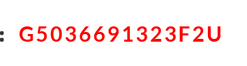

Fontsize:30px Fontfamily: Lato Color: # fe0000 Font weight: bold





Fontsize:33.38px Fontfamily: Lato Color: # 010101

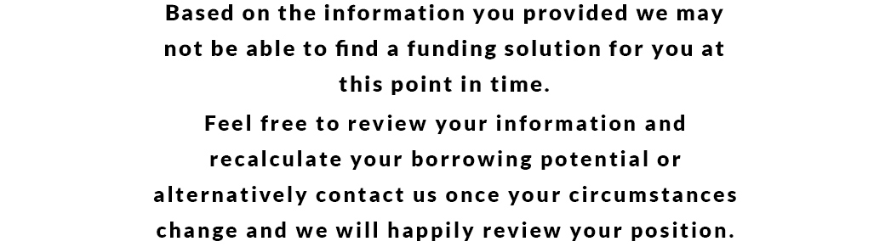

Fontsize:25.26px Fontfamily: Lato Color: # 010101